Software Development ISU –PROPOSAL

ICS4U

Ms. Brace

Kathryn Xing

Jan 2016

**Topic:** Internet of Things

**Brief Description:**

This python based application is an educational game about the basic concepts of Internet of Things.

The internet of things comes together with 3 basic components –machines, sensors and a cloud-based application to interpret information. This program has a brief introduction on these components, each with a recognizable icon.

This game allows users to control the direction of the ‘signal’ as it moves forward (background changes constantly) and avoids obstacles on both sides. The ‘signal’ will first be sent at the beginning of the game in the form of a straight line, and has to travel to a recognizable sensor without touching any obstacles. User’s ultimate goal is to score as high as possible by successfully avoiding obstacles and reaching destinations

**Flowchart:**

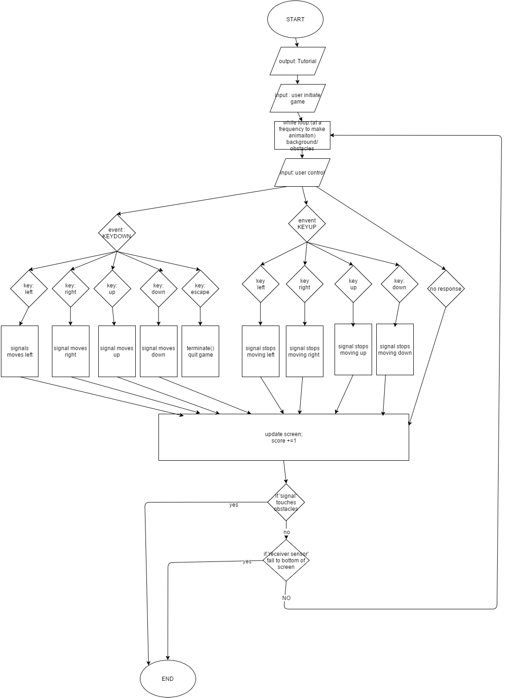

**Pseudocode:**

Import pygame, random, sys

Global Variables:

Window settings (width, height, etc.)

def terminate():

pygame.quit() –quit game

def drawText (text, font, surface, x, y):

create text object with given properties

show text on screen

def Tutorial:

--start screen

show background

drawText (description)

show each component of Internet of Things

(sensor, signal, machine, cloud-based app.)

drawText (explanation of each)

drawText (how to play)

def waitForPlayerToPressKey():

while loop:

check if user pressed ‘Esc’ or equivalent

terminate()

return True

return False

def signalRecieved(playerRect, receiver):

for loop going through the list of receiver sensors:

if touches:

remove the receiver sensor

return True

return False

def signalBlocked(playerRect, obstacles):

for loop check if signal touches obstacles:

return True

return False

def main ():

pygame.init()

mainClock = pygame.time.Clock()

initialize ‘windowSurface’ with global variables

import sounds

load ‘background’ image

load ‘Sensor1’ image

load ‘Sensor2’ image

load ‘Machines’ image

load ‘Signal1’ image

get_rect –to set up the image as a manipulatable object

update display

*waitForPlayerToPressKey*()

topScore = 0

while True:

set up variables:

--list of ‘obstacles’

--list of ‘end sensors’

--current score = 0

Set the initial position of ‘signal’

Set Boolean var. for direction movements *False*

(moveRight, moveUp, moveDown, moveLeft)

Play music

While loop: (actual game loop)

Each time print new images to the window at a constant frequency

(animation)

Score+=1

For loop:

--go through a list of events in pygame.event

If quit:

*Terminate*()

If KEYDOWN:

Check which key has been pressed;

If direction keys are pressed:

Correspondent Boolean var. set true

If KEYUP:

Check if direction keys are released:

Correspondent Boolean var. set false again

Adding ‘receiver sensor’ objects to list:

Same size, setting

At a slower rate

Moving at constant speed

Adding obstacles objects to list:

Random size, get_rect

At a constant rate

Moving obstacles:

For loop go through list:

.move_ip()

Delet obstacle objects as they fall past the bottom (for loop)

Moving signal (player control):

According to the detected event (moveRight, moveLeft, etc.):

Move ‘signal’ at a constant rate initialized as global var.

Paint windows background

Paint textObjects (topscore, score)

Paint ‘signal’

For loops pain each obstacle in list

For loops paint each sensor in list

Update windows display

If *signalBlocked*():

Check topscore: replace with a heigher score

Break

MainClock.tick(FPS)

Stop music

DrawText (game over, instructions)

Update display

waitForPlayerToPressKey()

Project Management:

Jan 6th proposal

Jan 7th in class time – class&method structure

Jan 10th FRI-SUN 1st program tested

Jan 11th- 16th ---testing adding features

**If I have time**:

Min Space between two obstacles allow user to pass

2 or more signals at a time

Increase difficulty as it get more points

Speed adjustment

Multiple lives